CC2101 Software Engineering Assignment 3


Deliverable no.1

School of Systems and Technology UMT Lahore Pakistan

NAME: NIMRA FAYSAL
ROLL NO F2024065140
SECTION: W8
SOFTWARE ENGINEERING

PROJECT NAME:
SECURE CONTACT LOG

SEQUENCE DIAGRAM

A sequence diagram is an easy way to show who is involved in a system and how they communicate with each other, one step at a time.
It helps us understand the flow of messages, the order of actions, and how a task is completed from start to end in a system.

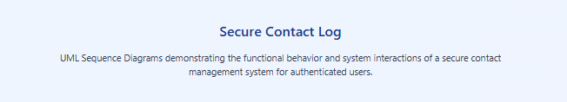

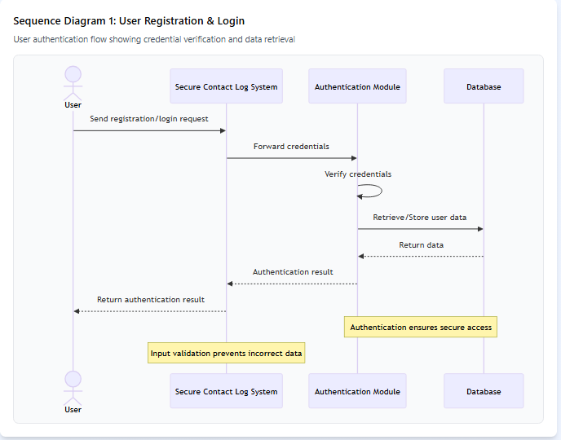

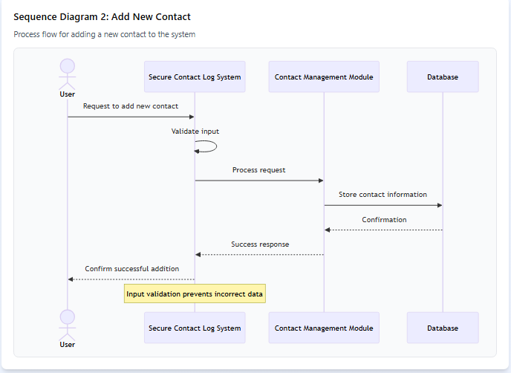

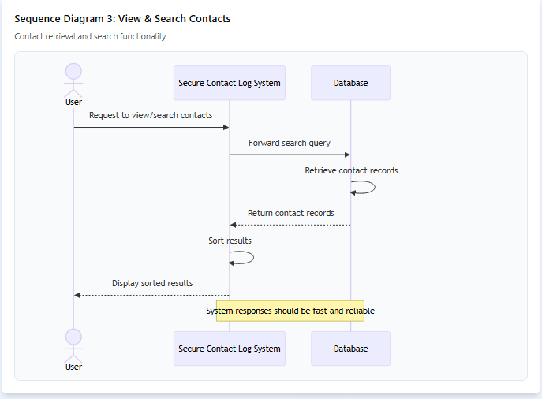

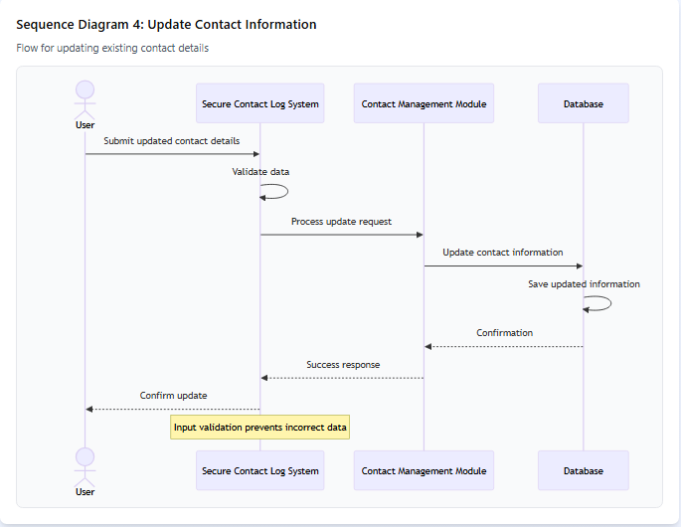

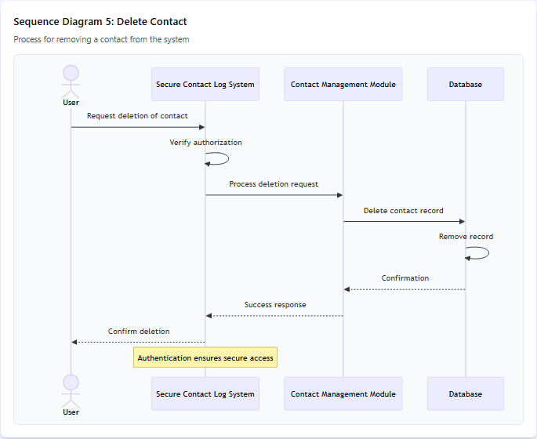

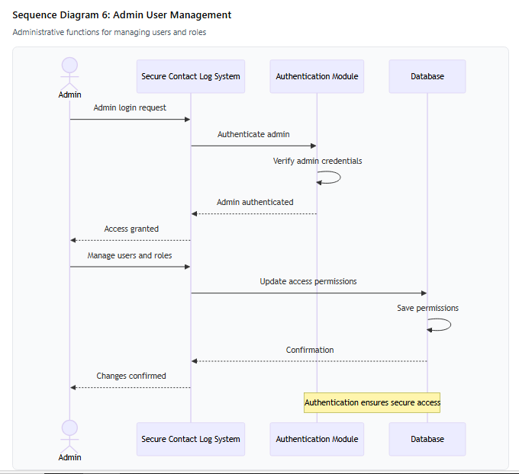

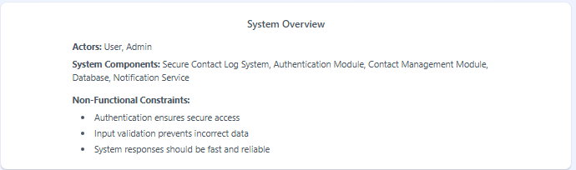

Main Components:
- Vertical lifelines for each participant (User, Admin, System components)
- Synchronous message arrows showing the interaction flow
- All 6 diagrams as specified: User Registration & Login, Add New Contact, View & Search Contacts, Update Contact Information, Delete Contact, and Admin User Management
- The yellow box is a warning notification that appears when you manually edit certain auto-generated files indicating non-functional constraints on relevant diagrams

https://www.figma.com/make/izSuPHqG5qGRWJb9DvMHGV/UML-Sequence-Diagrams?t=l9Vert7ORjAKBZFH-1

